**Problem Statement:**

**Perform and explain the code flow and the associated result for the below tasks. Candidates should**

**create and use their own dataset for the same. Share the screenshot of the commands used**

**and its associated result.**

## **● Transfer data between Mysql and HDFS (Import and Export) using Sqoop.**

**Importing Data from Mysql to HDFS**

**Create table in Hive:**

create database acad;

create table company

(

id int,

name string,

location string

);

**This table will be stored in hive deault location : /user/hive/warehouse/acad.db/company**

**Check data in hive table(Data does not exist)**

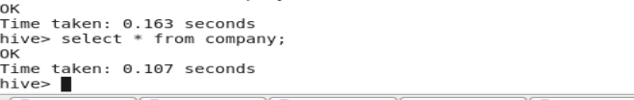

**Sqoop Command to import data:**

sqoop import --connect jdbc:mysql://localhost/b1 \

--username 'root' -P --table 'company' \

--hive-import --hive-table 'company' -m 1 \

--warehouse-dir /user/hive/warehouse/acad.db;

**Explanation(--connect to specify connection string, --username to specify the user name of the db, -P to specify the password at run time to maintain security, --hive-import –hive table to specify importing data into hive table company ,–m 1 to specify no of mappers if we omit this default mapper task will be four , --warehouse-dir where data will be stored)**

**Check data in warehouse directory of hdfs:**

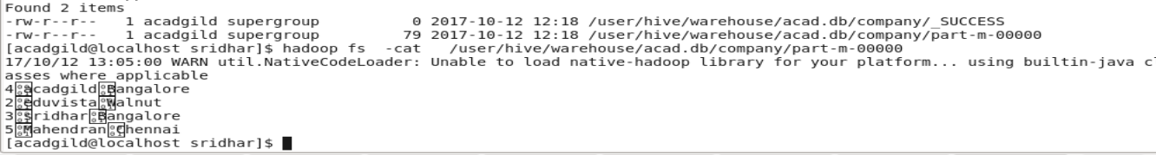

**Check data in hive table company using select * from company (data got loaded)**

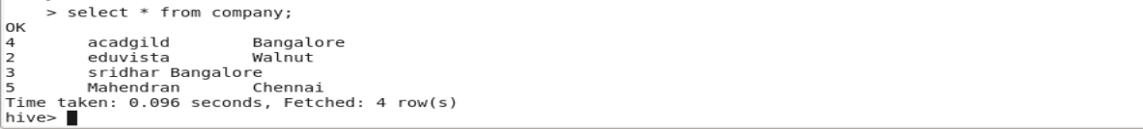

**Exporting Data from HDFS to Mysql**

**Create table in Mysql using create statement**

create table b1.company

(

id int,

name varchar(20),

location varchar(20)

);

**Check data do not exist in both table (Data does not exist)**

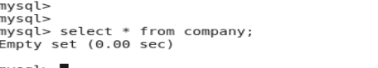

**Check HDFS data to be exported:**

hadoop fs -cat /user/acadgild/sridhar/assignment/part-m-00000

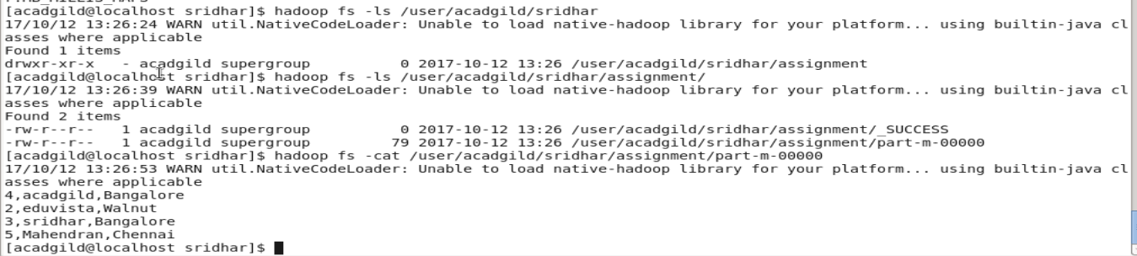

**Sqoop Export:**

sqoop export --connect jdbc:mysql://localhost/b1 \

--username 'root' -P --table 'company' --export-dir '/user/acadgild/sridhar/assignment' \

--input-fields-terminated-by ',' -m 1 --columns id,name,location \

**Explanation(--connect to specify connection string, --username to specify the username of the db, -P to specify the password at run time, --export-dir to specify the directory from where the data will be exported,--input-fields-terminated-by ',' to specify fields are terminated by ‘,’, -m 1 to specify the no of mapper tasks, --columns to specify the columns to be exported**

**)**

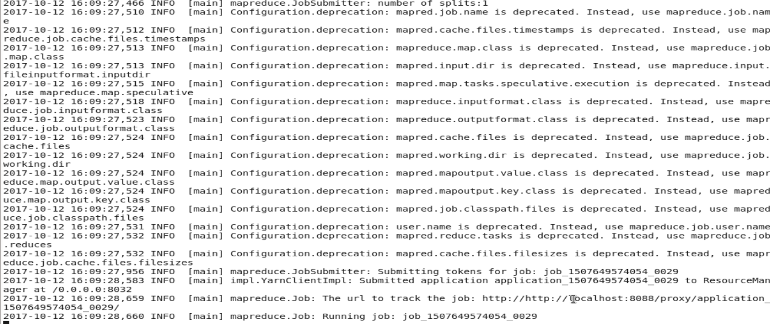

**Check Data in mysql table company (data got exported):**

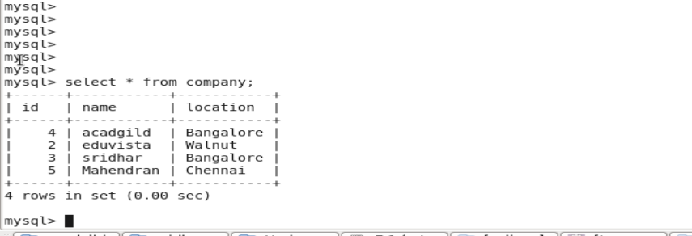

## **● Transfer data between Mysql and Hive (Import and Export only selected columns) using Sqoop.**

**Importing data from Mysql to Hive Table**

**First create company Table in mysql using create statement:**

create table company

(

id int,

name varchar(20),

location varchar(20)

);

**Load data into company table:**

insert into company values(4, 'acadgild','Bangalore');

insert into company values(2, 'eduvista','Walnut');

insert into company values(3, 'sridhar','Bangalore');

insert into company values(5, 'Mahendran','Chennai');

**Check data in mysql table company using**

select * from b1.comapny ;

B1 is the database used

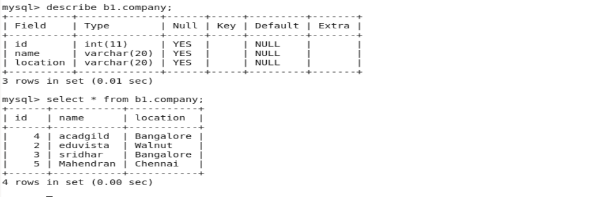

**Next Create table in Hive :**

Using create statement

create database acad; //database acad

use acad;

create table company

(

id int,

name string,

location string

**Check data do not exist on hive** using select * from company



**Run the Sqoop Import :**

sqoop import --connect jdbc:mysql://localhost/b1 --username 'root' -P

--table 'company' --hive-import --hive-table 'company' -m 1

--warehouse-dir /user/hive/warehouse/acad.db;

--columns "id,name"

**Explanation( --connect to specify the connection string,**

**--username to specify the username of the db, -P to provide password during run time so to maintain security, use –hive-import and provide –hive-table <<table_name>>**

**--warehouse-dir is the parent directory in hdfs where the data will be stored**

**--columns “id,name” to import only selected columns)**

**Check data on warehouse directory**

hadoop fs -cat /user/hivewarehouse/acad.db/comapny/part-m-00000

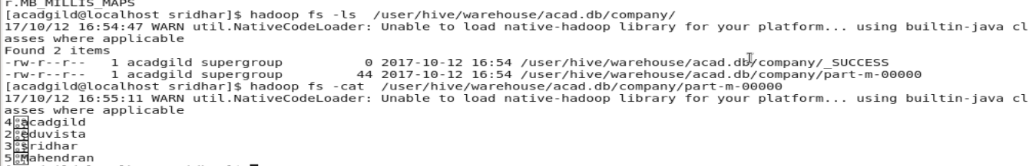

**Check data on hive after import using query select * from company**

**Only data for id and name got imported**

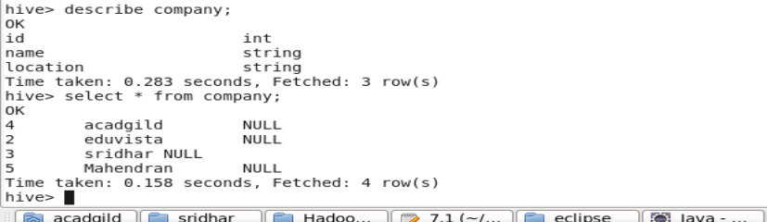

**Exporting data from Hive to Mysql:**

**Create table in Hive using create statement:**

create database acad;

use acad;

create table company

(

id int,

name string,

location string

**Check data on hive using select * from company:**

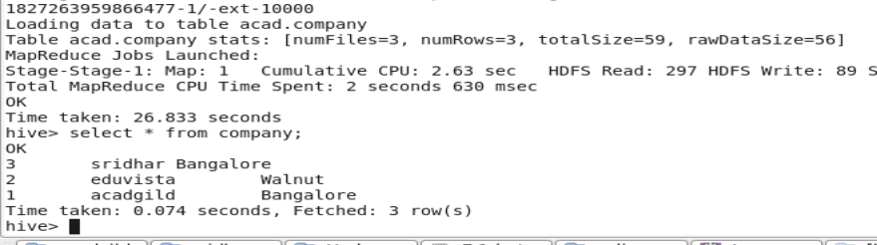

**Check data in mysql using create statement:**

create table company

(

id int,

name varchar(20),

location varchar(20)

);

**Check data in mysql (Data do not exist)**

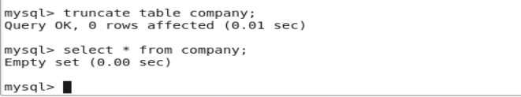

**Run sqoop export:**

sqoop export --connect jdbc:mysql://localhost/b1 \

--username 'root' \

-P \

--table company \

--export-dir /user/hive/warehouse/acad.db/company \

--input-fields-terminated-by '\001' \

--input-lines-terminated-by '\n' \

--num-mappers 2 \

--batch \

--input-null-string nvl \

--input-null-non-string -1

--columns "id,location"

**Explanation( --connect to specify the connection string,**

**--username to specify the username of the db, -P to provide password during run time so to maintain security, --columns “id,name” to export only selected columns ,**

**--num-mappers to specify mapper task, --batch to be executed in batch mode,**

**--export-dir to specify the directory from where data will be exported, -–table to specify the mysql table name where data will be stored, --input-lines-terminated-by to specify input fields are terminated by new line**

**--input-fields-terminated-by '\001' to specify fields terminated by '\001'**

**--input-null-non-string :The string to be interpreted as null for non-string columns**

**--input-null-string nvl : The string to be interpreted as null for string columns )**

**Check data in mysql by using select * from company**

**Only data for id and location got exported**

